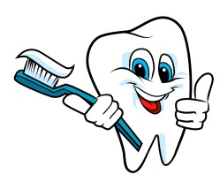February Newsletter from Nurse Kris

**February is National Children’s Dental Health Month!** Did you know that reports show that American students miss **51 million hours** of school every year because of oral health problems? And students who are absent miss critical instruction time—especially in early grades where reading skills are an important focus and the building blocks of future learning.

Encourage your child to brush their teeth for two minutes, two times per day, and read for 20 minutes as a way of building good oral health and literacy habits.



North River Pediatric Dentistry will be visiting our school to present a special program on preventative dentistry and dental hygiene. Details coming soon! If your family needs help finding a dentist, please let me know! I will be glad to help!

______________________________________________________________________________

Is your child too sick for school???

* **PLEASE keep children home during the course of a fever and for an *additional* 24 hours after the fever has passed without fever reducers.** Your child may be carrying something **very contagious.**
* **PINK EYE:** Pink eye, also known as conjunctivitis, is caused by a bacterial infection and is **EXTREMELY CONTAGIOUS**! Signs and symptoms include: redness, itching, swelling, matting, and tearing. It is usually treated with antibiotic drops or ointment. It is our policy that a child waits **at least 24 hours** after starting treatment before returning to school.

If your child still seems tired, pale, with little appetite, not tolerating solid foods, and generally "not him/herself", **PLEASE do not** send him/her to school. If you send your child to school to "see how they feel in a little while", you are potentially exposing other students, and our staff, to a communicable illness.  This ripple effect exposes classmates and then their siblings and family members to the illness.